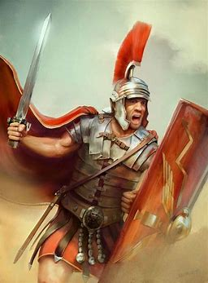
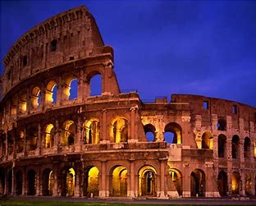
Year 5 History Creative Homework:

Historian fact file

Start date: Friday 16th February
Completion date: Friday 1st March

History homework explained

For this half term , please can the children create a fact file about one of the historians below. Please ensure that these are well-presented as they will be put in books as a piece of work. These can be handwritten or produced digitally to be printed off.

Choose one historian from the list below:
Andrew Roberts
Antony Spawforth
Henriette Van Der Blom

Please can the fact file be created on an A4 piece of paper as I will put them in a folder in their history books.

Be creative as you wish. I want to see lots of facts, colours, and pictures!

Kind Regards,
Miss McInnes

