Year 4 History Homework

Research Project – Influential Figures during the Victorian era
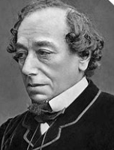
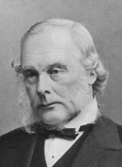
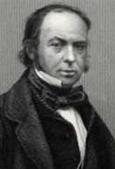
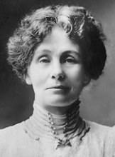
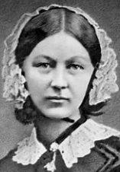
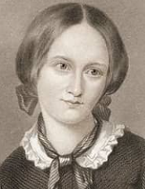

Start date: Friday 16th February

End date: Wednesday 28th February

History homework explained:

This little project is linked to our current history topic, ‘Victorian Britain’.

Over the holiday, I would like your son/daughter to choose one of the influential figures set out below, then do some research on them:

- Charlotte Bronte
- Florence Nightingale
- Emmeline Pankhurst
- Isambard Kingdom Brunel
- Joseph Lister
- Benjamin Disraeli

I would like you to present it in one of the following formats:

- A fact file
- A poster
- An information leaflet
- An information text
- A painting, with an informative caption
- A sculpture, with an informative caption

I would like to celebrate your child’s homework in class on Friday 1st March, so please can they be brought in on by Wednesday 28th February.

Kind regards,

Mr Haslam

