
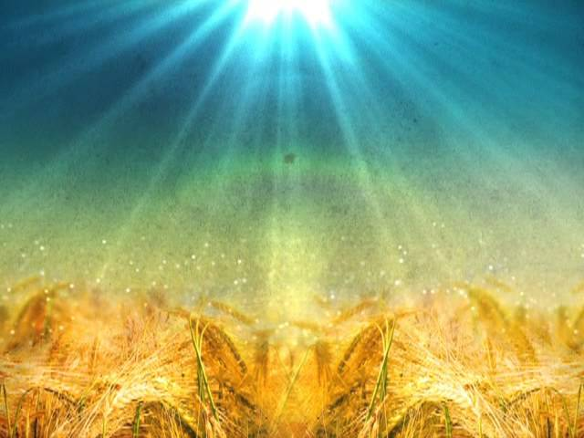
Year 6 Religious Education Creative Homework:

‘Why do Christians say thank you at Harvest?’

Start date: Friday 12th September
Completion date: Friday 3rd October

Religious Education Creative Homework explained:

This half-term’s RE homework is a creative challenge linked to Harvest. We would like your child to answer the question of ‘Why do Christians say Thank You at Harvest time?’

This is a creative piece of homework that can be presented in any way your child sees fit. We would like to celebrate the homework in three weeks’ time and display them along the school corridors and in the classroom, so please encourage them to be as creative as possible.

Possible options on how to present this RE homework

This is not an exhaustive list, just some possible ideas as to how they could present their homework to answer the question of ‘Why do Christians say Thank You at Harvest?’:

- Poster
- Leaflet
- 3D model
- Scrap booking
- Drawing / picture
- Explanation Text
- PowerPoint slides
- Painting / Decoupage
- Cartoon strip (Graphic Novel)

We would like to celebrate your child’s homework in worship on Friday 3rd October, so please can it be brought into school or emailed to me on or before this date.

Kind Regards,

Mr Haslam

